Session 3: The basics of Client-Server

Objectives
We will cover:
- Basic concepts of the “client-server” architecture,
- Examine some of the ways of allocating resources within the framework provided by that architecture.

3.1 Introduction to Client-Server Architecture

Definition of terms
Client – An application program that establishes connections for the purpose of sending requests.

Server – An application program that accepts connections in order to service requests by sending back responses.
Clients often tend to be desktop PC's or workstations, while servers are more powerful machines.
The client-server model is an extended way of sharing resources.

A server is not a host, but a program or process which runs on a host. A client is any process which requires the services of a server. In Unix-like systems, servers are called daemons. In Windows they are just called services. A server is often regarded as a large machine which performs some difficult and intensive task for the clients (an array of workstations). A server is often regarded as a large machine which performs some difficult and intensive task for the clients (an array of workstations).

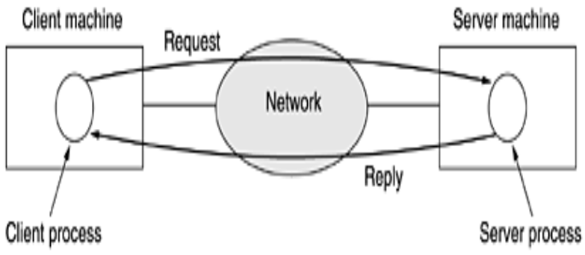

Figure 3.1: Client-Server Architecture

In reality, there are many levels at which the client-server model applies. For example, many system calls can be regarded as client-server interactions, where the client is any program and the server is the kernel.

The term client-server denotes a type of relationship between entities. The entities we are software applications running on networked computer systems. There are many such types of possible relationships (such as a hierarchy) between multiple entities, but we will only examine two here: “peer-to-peer” and “client-server”. Protocols at the communication and application layers must be compatible.

Client/server networking provides advantages in the areas of performance, scalability, security and reliability, but is more complicated and expensive to set it up. This makes it better-suited to larger networks. Over time, however, there has been a steady evolution towards client/server networking, even on smaller networks. Years ago it was common to see even networks with 20 to 50 machines using the peer-to-peer model; today, networks with only a half-dozen machines sometimes are set up in a client/server mode because of the advantages of centralized resource serving.

In the client-server model, a client program running on one end system requests and receives information from a server running on another end system. This client-server model is the most prevalent structure for Internet applications. The Web, e-mail, file transfer, remote login (e.g., Telnet), newgroups and many other popular applications adopt the client-server model. Since a client typically runs on one computer and the server runs on another computer, client-server Internet applications are, by definition, distributed applications. The client and the server interact with each other by communicating (i.e., sending each other messages) over the Internet.

3.2 Examining a “Peer-to-Peer” Relationship
In a peer-to-peer relationship, all entities have equal standing with one another, and all are equally capable of running the same set of services. In many ways, this relationship is the easiest type to recognize, configure, and manage. This does not mean that it is necessarily the most efficient or cost-effective way of allocating computer resources.

In peer-to-peer configuration, all of the individual systems are configured (more or less) alike. They have relatively equal amounts of resources (e.g., disk, memory, and CPU power), and all resources are equally shared among the various systems in the group. Each machine is completely capable of performing any task that a particular user may desire, without the involvement of, or reliance on, another system’s resources.

Underutilization of resources is common in a peer-to-peer network where there are multiple applications types being used. The underutilization of resources on some systems, along with full or overutilization on others can mean that some users are not able to get their tasks completed in the optimum amount of time, while others may have no difficulties. Here is an example of how misallocation of resources in a networked environment can actually cost money.

3.3 The Client-Server Relationship
In a client-server relationship, there are at least two types of logical entities involved: the client entity and the server entity. It is important to note at this point that the term client-server may be applied either to hardware (computer system) or to software (applications) running on the hardware. This is one potential point of confusion, as the hardware may be configured differently to run the client software or the server software, but does not necessarily have to be.

In the case of software entities, it is possible that both client and server may exist on the same computer system or be split across multiple systems in the network. How the actual tasks that an application performs are split between the client and the server entities will vary, usually determined by the application’s designer

Unlike the peer-to-peer environment, the client-server relationship is not one of equal capability between client and server entities:
- The server entity “possesses” and manages a well-defined set of resources on behalf of its client or clients.
- The client-server model may also be characterized as a “request-response” interaction. To use the resource, the clients must make requests to the server entity. The server responds to, services, or “serves” its client’s requests for the resource that it manages.
- Since the client-server relationship is a logical3 one, nothing prevents both the client and the server components of an application from running on the same underlying hardware.

In this type of environment, there are usually N clients to each server, with the server providing all of the services associated with its resource to multiple clients. The client-server relationship may be thought of as a many-to-one relationship.
The number of clients that a server can handle depends on several factors, including:
- the type of resource being managed,
- the number of total simultaneous requests, and
- the request frequency from each client.
- One other important performance factor is the type of connection between the client and the server and its relative “health”.

3.4 Client-Server Application Configurations and Components
Within the term client-server, there are many possible application configurations. The configuration of client-server architecture is determined by where the associated application is broken into separate components.
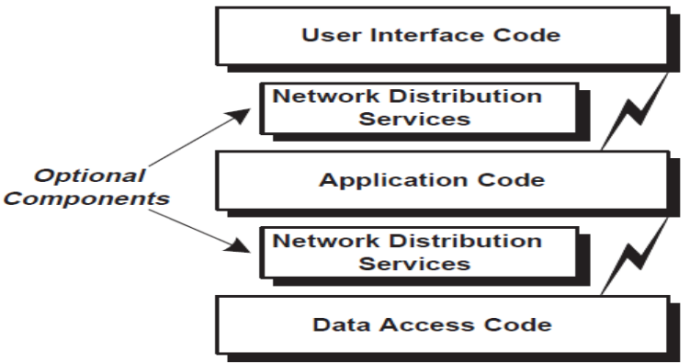

Figure 3.2 Client-Server Application Components

At the most basic level, the application may be split into several different components: the graphical user interface (presentation logic), application logic, and data management logic.

3.5 Client-Server Distribution Services
While describing the client-server application architecture, we did not venture beyond the conceptual description of the application being split into components and “glued” together with “distribution services”. Examining the available distribution services in an environment is an important aspect of both good design and analysis. If the necessary services are not available or reliable, client-server applications may quite literally fall apart.

The services used to allow distribution of client-server application components include:
- Remote procedure call facilities (RPC),
- Directory services, system management services,
- Performance measurement services, load balancing, and a whole host of other potential components.

These services may be distributed across multiple systems or reside on a single server. When designing an environment, it is easier to separate the services as if they were running on their own computer systems, only collapsing the relationships between services and the physical server system when the final hardware configuration is determined.

3.6 How Do I Recognize a Client-Server Relationship?
When confronted by something that purports to use a client-server model, start by asking the following questions:
- What is the resource that is being managed?
- Who is doing the resource management?
- Who is using the resource?
With the answers to these questions in hand, try drawing a picture that represents the relationships among the entities being examined.
You should see:
• A clear logical or physical division between the manager and the users of the resource (the server and the clients)
• Usually, one server to multiple clients
• A clear division of “intelligence” or “responsibility” with regards to managing the resource, with the client being the least capable of the two entities

Client-Server Characteristics

Briefly, the Client-Server characteristics are:
- Strong emphasis on bringing user-friendly, familiar apps and interface to the user
- Applications are distributed, but data is centralized
- Encourages the use of open and modular systems
- Networking is fundamental to the process (“the network is the computer”)

Importance of the Client-Server Model
But why is the client-server model important? Why does a large portion of the industry focus on this particular way of designing applications? There are several very good reasons to consider client-server design in your computer environment:
• The per seat cost of a computerized solution may be lower with the client server model.
• Specialized hardware may be used to provide resource-intensive services, improving client performance.
• General-purpose hardware may be specifically tuned to perform the specialized service, improving client performance.
• Measuring (and therefore managing) the usage of a service may be easier if it is localized to specific places in the environment.
• The clients may be insulated from changes in the server environment.
• The client-server model provides better scaling than other usage models.

Whenever a server must provide access to a specialized resource, there are two common ways to approach the situation:
- Choose a specialized machine type, if the need warrants it, or
- Choose a general purpose machine that is capable of providing the service if properly tuned.
The specialized computer usually provides a unique service, or provides it in a way that no other machine can, often at an extra cost. A general-purpose computer can be moved from place to place and retuned to meet the new service needs.

Advantages of Client-Server Computing

Distributed systems means redundancy and robustness

Distributed processing provides power without monopolization of resources

Modularity allows choices in hardware and software

Upgrading and growth are relatively easy

Disadvantages of Client-Server Computing

Maintenance problems are more difficult with different vendors and interconnected systems

Difficult to find support tools for applications developed in-house

Requires different skills sets from software developers (Windows, Mac, RDBMS rather than COBOL, C)

Classes of Client-Server Applications
- Host-based processing – traditional mainframe/central host environment; workstation role is limited to emulation
- Server-based processing – Client primarily provides interface
- Client-based processing - All application processing on client
- Cooperative processing – Processing distributed optimally

Types of Servers
- Application Servers  - Audio/Video Servers  - Chat Servers  - Fax Servers  - FTP Servers | - Groupware Servers  - IRC Servers  - DNS Servers  - List Servers  - Mail Servers | - News Servers  - Proxy Servers  - Telnet Servers  - Web Servers  - Z39.50 Servers  - DHCP Servers

3.7 Summary
Client-server architectures,
- A system with separate systems some providing resources and others accessing the resources.
- Server based networks provide centralized control over network resources, primarily by instituting network security and control through the server’s own configuration and setup.

Advantages of Server-Based Network
- Centralized user accounts, security, and access controls to simplify network administration.
- More powerful equipment means more efficient access to network resources.
- A single password for network login deliver access to all.
- Server-based networking makes the most sense for networks with 10 or more users or any networks where resources are used heavily.

Disadvantages of Server-Based Network
  - At worst, server failure leads to whole network failure.
  - Complex, special-purpose server software requires allocation of expert staff, which increases expenses.
  - Dedicated hardware (server) and special software (NOS) add to the cost.

Suitability of Server-Based Network
- There are more than ten people in your organization.
- Many of the people are not sophisticated computer users.
- The organisation maintains information that must be centrally controlled.
- A central administrator will be assigned for network setup and maintenance

3.8 Student Activity

Describe each type of server in Section 3.6 above

